Complement

🔹 What is Complement
# Source: AI Source: Provided by: [Data Path: Persons Table -> ID Column: 1, Name_En Column: Motasem Essam] -> From: [Chatgpt (GPT-4-turbo)] on [8/3/2025]
A complement is a word, phrase, or clause that completes the meaning of a predicate by giving more information about the subject or the object.
Complements are essential to the sentence—they are not optional like adjuncts.
🧠 Complements usually follow linking verbs (like be, seem, become) or transitive verbs.

✅ Main Types of Complements:
# Source: AI Source: Provided by: [Data Path: Persons Table -> ID Column: 1, Name_En Column: Motasem Essam] -> From: [Chatgpt (GPT-4-turbo)] on [8/3/2025]
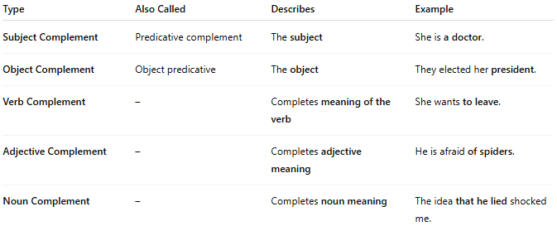
Type | Also Called | Describes | Example
Subject Complement | Predicative complement | The subject | She is a doctor.
Object Complement | Object predicative | The object | They elected her president.
Verb Complement | – | Completes meaning of the verb | She wants to leave.
Adjective Complement | – | Completes adjective meaning | He is afraid of spiders.
Noun Complement | – | Completes noun meaning | The idea that he lied shocked me.

✅ 1. Subject Complement
# Source: AI Source: Provided by: [Data Path: Persons Table -> ID Column: 1, Name_En Column: Motasem Essam] -> From: [Chatgpt (GPT-4-turbo)] on [8/3/2025]
- Follows a linking verb (be, seem, become, appear, etc.)
- Renames or describes the subject
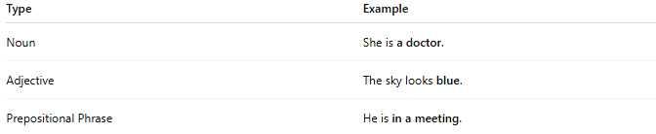
Type | Example
Noun | She is a doctor.
Adjective | The sky looks blue.
Prepositional Phrase | He is in a meeting.

✅ 2. Object Complement
# Source: AI Source: Provided by: [Data Path: Persons Table -> ID Column: 1, Name_En Column: Motasem Essam] -> From: [Chatgpt (GPT-4-turbo)] on [8/3/2025]
- Follows a direct object
- Describes or renames the object
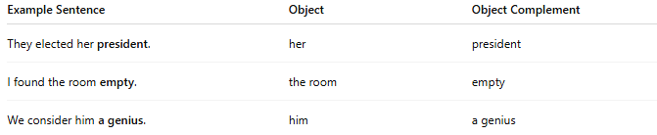
Example Sentence | Object | Object Complement
They elected her president. | her | president
I found the room empty. | the room | empty
We consider him a genius. | him | a genius

✅ 3. Verb Complement
# Source: AI Source: Provided by: [Data Path: Persons Table -> ID Column: 1, Name_En Column: Motasem Essam] -> From: [Chatgpt (GPT-4-turbo)] on [8/3/2025]
- Completes the verb’s meaning
- Often appears as an infinitive, gerund, or clause
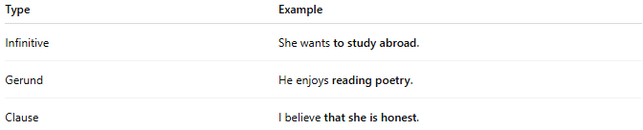
Type | Example
Infinitive | She wants to study abroad.
Gerund | He enjoys reading poetry.
Clause | I believe that she is honest.

✅ 4. Adjective Complement
# Source: AI Source: Provided by: [Data Path: Persons Table -> ID Column: 1, Name_En Column: Motasem Essam] -> From: [Chatgpt (GPT-4-turbo)] on [8/3/2025]
- Completes the meaning of an adjective
- Often introduced by prepositions or "that" clauses

Example | Adjective | Complement
She is proud of her work. | proud | of her work
I’m sure that he will come. | sure | that he will come

✅ 5. Noun Complement
# Source: AI Source: Provided by: [Data Path: Persons Table -> ID Column: 1, Name_En Column: Motasem Essam] -> From: [Chatgpt (GPT-4-turbo)] on [8/3/2025]
- Completes or explains the meaning of a noun
- Usually a clause following the noun
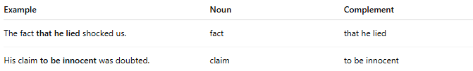
Example | Noun | Complement
The fact that he lied shocked us. | fact | that he lied
His claim to be innocent was doubted. | claim | to be innocent

✅ Complement vs. Adjunct:
# Source: AI Source: Provided by: [Data Path: Persons Table -> ID Column: 1, Name_En Column: Motasem Essam] -> From: [Chatgpt (GPT-4-turbo)] on [8/3/2025]
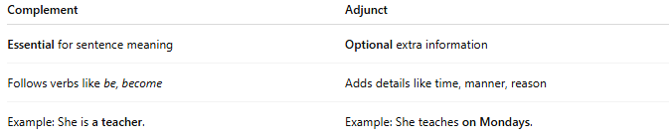
Complement | Adjunct
Essential for sentence meaning | Optional extra information
Follows verbs like be, become | Adds details like time, manner, reason
Example: She is a teacher. | Example: She teaches on Mondays.

📝 Summary:
# Source: AI Source: Provided by: [Data Path: Persons Table -> ID Column: 1, Name_En Column: Motasem Essam] -> From: [Chatgpt (GPT-4-turbo)] on [8/3/2025]
- Complements are required parts of a sentence structure.
- They complete the meaning of the subject, object, verb, adjective, or noun.
- Common forms: nouns, adjectives, infinitives, gerunds, clauses, prepositional phrases.

